Security And System Monitoring Task
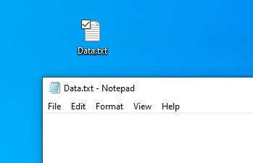
Virus Total:
Target File: “Data.txt” and it’s a txt file
Tool used: virustotal.com
The suspicious content’s type is txt file called Data.txt
The content is Safe
The Plan to use the tool is to determine the suspicious file is safe or dangerous.
After uploading the file and scanning it the result will be free
Documenting the steps:
- Determining the suspicious file and its name is “Dat.txt”
- The objective of the task is to determine if the suspicious file is safe or not safe
- The tool used is Virus Total for checking the file safety
- The type of the suspicious file is txt file but virus total says that its unknown
- The file is Safe
- There is no malicious found.
- Type of suspicious is wrong suspicious and the file is a safe file.
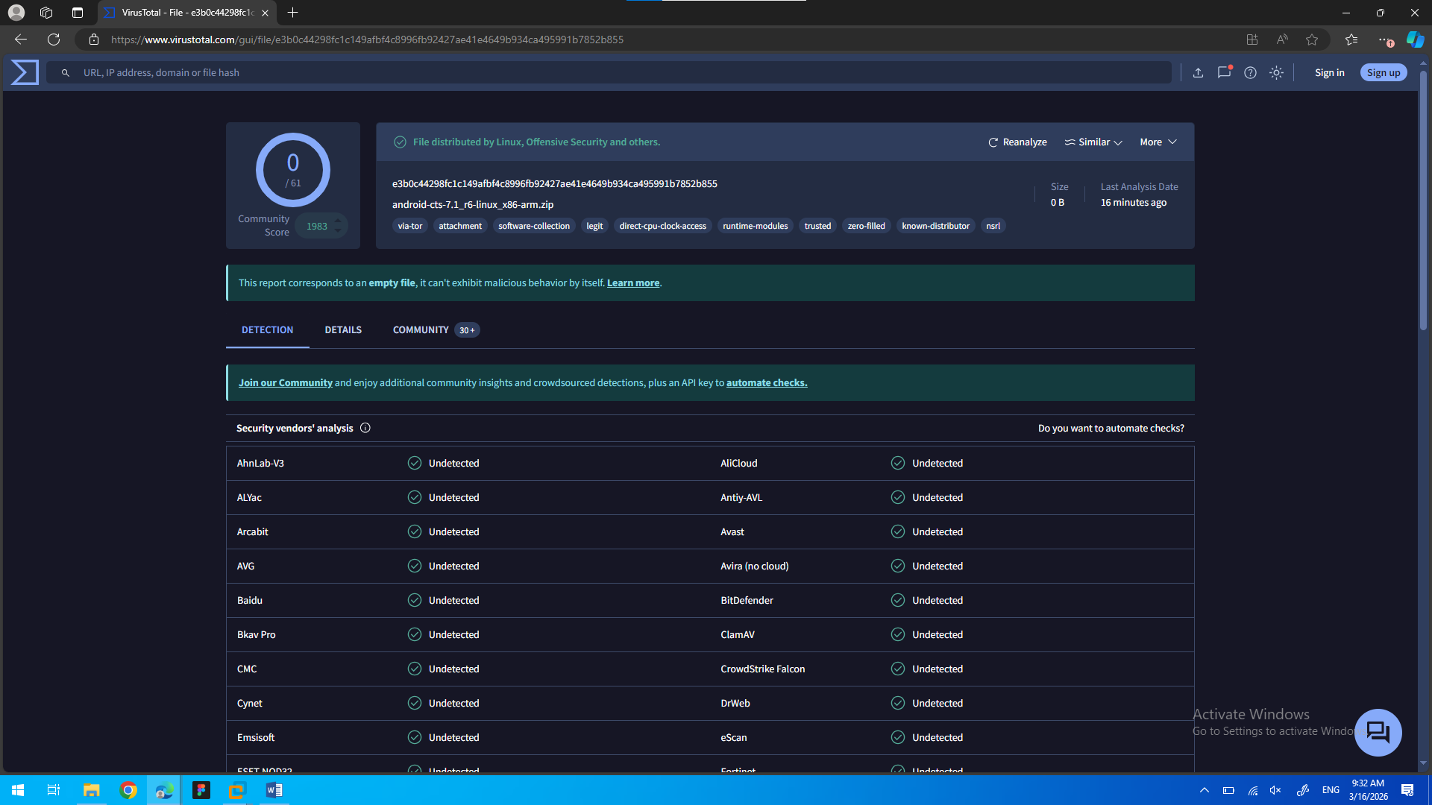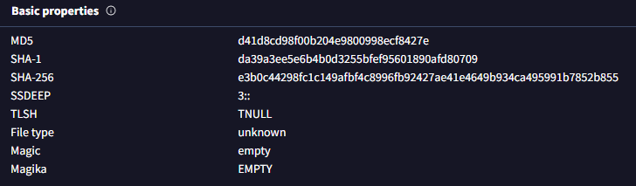

Encryption and decryption with openssl:
The tool used for encryption is “openssl”
The type of the data needs to be encrypted is at rest using symmetric encryption
The password used is “FORTEST!=55”
The algorithm used is “-aes-256-cbc” with –salt
Commands used for encryption:
“openssl enc -aes-256-cbc -salt -in sensitive_data.txt -out sensitive_data.enc”
Commands used for the decryption:
“openssl enc -d -aes-256-cbc -in sensitive_data.enc -out sensitive_data_decrypted.txt”
The documentation of the steps:
- Creating a file called “sensitive_data.txt” and add the text “This is an encrypted file” inside of the file.
- Encrypting the file with the command:
“openssl enc -aes-256-cbc -salt -in sensitive_data.txt -out sensitive_data.enc”
- Adding the Password “FORTEST!=55” for using it for encryption.
- Verifing the files are encrypted by showing the data inside the file using the command:
“cat sensitive_data.enc”
- Decrypting the file using the command
“openssl enc -d -aes-256-cbc -in sensitive_data.enc -out sensitive_data_decrypted.txt”
- Decrypting the file using the password “FORTEST!=55”
- Verifying the data inside the decrypted file are equal to the file before the encryption by viewing the decrypted file “sensitive_data_decrypted.txt” with the command:
“cat sensitive_data_decrypted.txt”

Screenshot of the commands used:
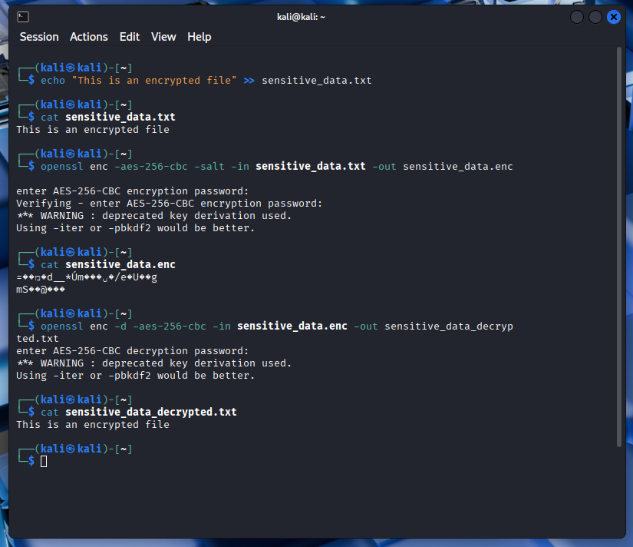
Screenshot of the files and the final result:
